**Key message** (aim for under 50 words) – super succinct summary of the issue

**Canada's transboundary marine resources provide important benefits. Climate-mediated shifts in species’ distributions are having uncertain feedbacks on marine systems and dependent communities. Such impacts may accentuate conflict over shared resources and highlight the need for bi/multi-lateral agreements that are agile, adaptive, cooperative, and science focused - with risk-based tools for stakeholder engagement - to promote effective governance.**

**Full, plain language paragraph** (about 100 words) **–** provides key points needed to understand *each element* of the key message.

Marine resources - including transboundary fish stocks - provide Canadians with numerous socio-economic and cultural benefits. Climate change has been associated with changes in productivity and shifts in species’ geographic ranges. Many current transboundary regulatory frameworks for fisheries do not have functionally agile mechanisms to address expected shifts, risking overexploitation and conflict between users. For effective governance, management agreements will need to: improve capacity and resourcing to both monitor and project climate change’s ecosystem effects; be nimble, cooperative and adaptive; clearly evaluate trade-offs; use risk-based tools to engage with stakeholders; and develop provisions to address the role of equity, as well as Indigenous rights.

**Conventional write-up** (685 words) more details to explain context, issue and avenues forward

**Canada** is bordered by three oceans, whose marine resources – including transboundary stocks[1] - provide important ecological, social, economic and cultural benefits. In 2016, British Columbia exports of Pacific hake, chinook salmon and Pacific halibut – all shared marine resources – accounted for CA$ 161.6 million {Government of BC, 2017 #6137}.

Climate change has led to substantial **geographic shifts** in marine animals, a pattern expected to continue or accelerate in the coming decades. These shifts arise through changing ocean conditions including temperature, pH and oxygen, which in turn alter trophic interactions, increase uncertainty about stock productivity, and confer vulnerability to pollution and exploitation {Perry, 2005 #1554;Ainsworth, 2011 #5973;Doney, 2012 #434;Cheung, 2018 #5966;Cheung, 2015 #5957;Cheung, 2016 #5377;Gruber, 2012 #6105}. Under rising temperatures, marine species have already been observed to shift poleward {García Molinos, 2015 #6139;Pinsky, 2012 #5686;Pinsky, 2018 #5803;Pinsky, 2013 #5215;Cheung, 2015 #5957;Poloczanska, 2016 #5448;Poloczanska, 2013 #4639;Weatherdon, 2016 #5554;Kintisch, 2015 #5971;Peterson, 2015 #5972} or into deeper water {Dulvy, 2008 #6140} to stay within their preferred temperature range. Greater proportions of Pacific hake (whiting), for instance, migrated northward into Canadian waters due to higher temperatures associated with the 1998 and 2015 El Niño events {Berger, 2017 #6143}.

Shifting stocks across international borders **challenge existing cooperative governance** structures in transboundary marine resource agreements (Table 1). By redistributing shared marine resources (Figure 1), climate change is essentially modifying the relatively static management context under which contractual and reciprocal rights {Wenar, 2015 #6146} and responsibilities were originally agreed {Ringius, 2002 #6144;United Nations, 1970 #6145;Mills, 2013 #5786}. Uncertainty around the magnitude and timing of climate-mediated changes {Hollowed, 2013 #6147;Brander, 2007 #6148} has the potential to accentuate conflict: it also challenges means to effectively and equitably generate pragmatic climate-related policy steps, further complicating the development of appropriate incentives {Miller, 2010 #5969;Polasky, 2011 #5970;Miller, 2007 #5968}.

Shifting stocks provide **opportunities for targeted, cooperative, science-based climate adaptation** **planning** for the responsible stewardship and effective governance of fish stocks and fisheries into the future. Existing management frameworks will need to improve their capacity for collaborative monitoring and the integration of multiple data streams into science-based, precautionary, management-relevant advice {Mills, 2013 #5786;Pinsky, 2018 #5803}. Greater flexibility, adaptive capacity, and responsiveness in management regimes would facilitate such developments {Favaro, 2012 #6149;Bailey, 2016 #6134}. Specific mechanisms that would support adaptation include: permit structures that facilitate entry into different/emerging fisheries or the provision of alternative livelihoods for fishers, assuring that monitoring is available iteratively at change-relevant scales, catch limits and schemes for capacity adjustment (e.g., license buy-back or tradable quota shares) {Mills, 2013 #5786}. Negotiations for climate-ready shared resources agreement will also need to reinforce trust, incentivize cooperation among all stakeholders {Miller, 2013 #5984}, and would benefit from engaging and/or training stakeholders in the use of risk-based tools.

**First Nations** communities have traditional knowledge that can effectively support adaptation to cyclic climate-induced changes and need to be included and considered fairly to achieve equity in all negotiations {United Nations Fish Stock Agreement, 1995 #6150}.

**Success in adaptation measures** will be measured by the ability for adaptation policy to achieve objectives while minimizing risks, and maximize benefits, while striving for equity and legitimacy.

Table 1 – Treaties dealing with transboundary marine stocks, which Canada is currently a member of

|  |  |  |  |  |  |  |
| --- | --- | --- | --- | --- | --- | --- |
| Treaty | Acronym | Ocean | Members | # Members | Species | # Species / species groups |
| International Pacific Halibut Commission | IPHC | Pacific | Canada and the United States | 2 | Pacific halibut | 1 |
| Pacific Salmon Commission | PSC | Pacific | Canada and the United States | 2 | Pacific salmon: chum, chinook, coho, pink, and sokeye | 5 |
| Whitening treaty | WT | Pacific | Canada and the United States | 2 | Pacific hake | 1 |
| Northwest Atlantic Fisheries Organization | NAFO | Atlantic | Iceland, Japan, the Republic of Korea, Norway, the Russian Federation, Ukraine, Canada, Cuba, Denmark (Faroe Islands and Greenland), the European Union, France (Saint Pierre et Miquelon), the United States | 12 | Atlantic cod, redfish, American plaice, yellowtail flounder, witch flounder, white hake, capelin, thorny skate, Greenland halibut, shortfin squid, northern shrimp | 11* |
| North Atlantic Salmon Conservation Organization | NASCO | Atlantic | Canada, Denmark (Faroe Islands and Greenland), the European Union, Norway, the Russian Federation and the United States | 6 | Atlantic salmon | 1 |
| North Pacific Anadromous Fish Commission | NPAFC | Pacific | Canada, Japan, the Russian Federation, the Republic of Korea and the United States | 5 | chum salmon, coho salmon, pink salmon, sockeye salmon, chinook salmon, cherry salmon and steelhead trout | 7 |

* The NAFO Convention applies to most fishery resources of the Northwest Atlantic except salmon, tunas/marlins, whales, and sedentary species. However, only 11 species (and 19 stocks) are officially managed by the commission.

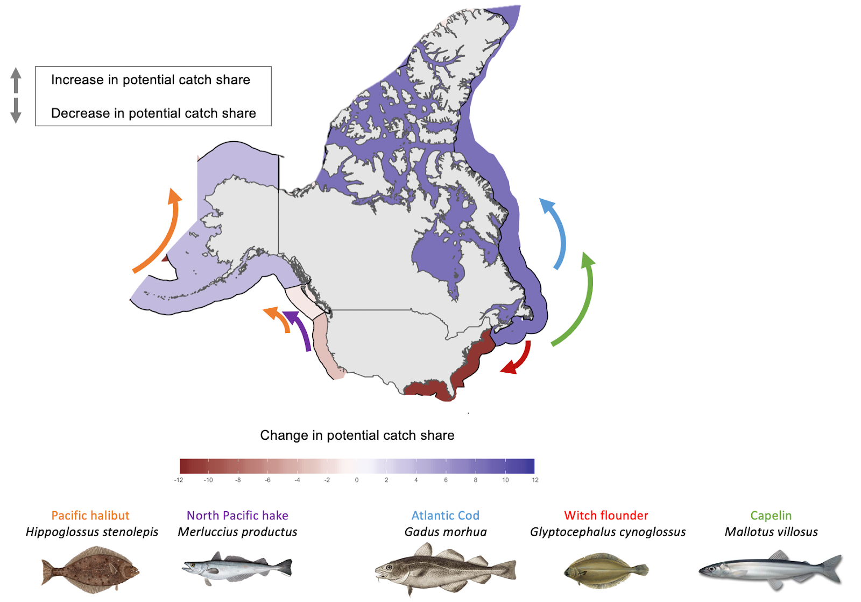

Figure 1 - Projected shifts in distribution of commercial transboundary fish species targeted by both American and Canadian fisheries by 2050 relative to 2014 under a high emission climate change scenario. Direction of the arrow represents key direction in shift. Arrows are colour coded according to chosen species.

**References**

1. Stocks that occur within the Exclusive Economic Zones (EEZs) of two or more coastal States {Gulland, 1980 #6138}. This section does not include considerations for provincial transboundary stocks or stocks that migrate through, or occur in, the high seas (international straddling stocks).